Week2
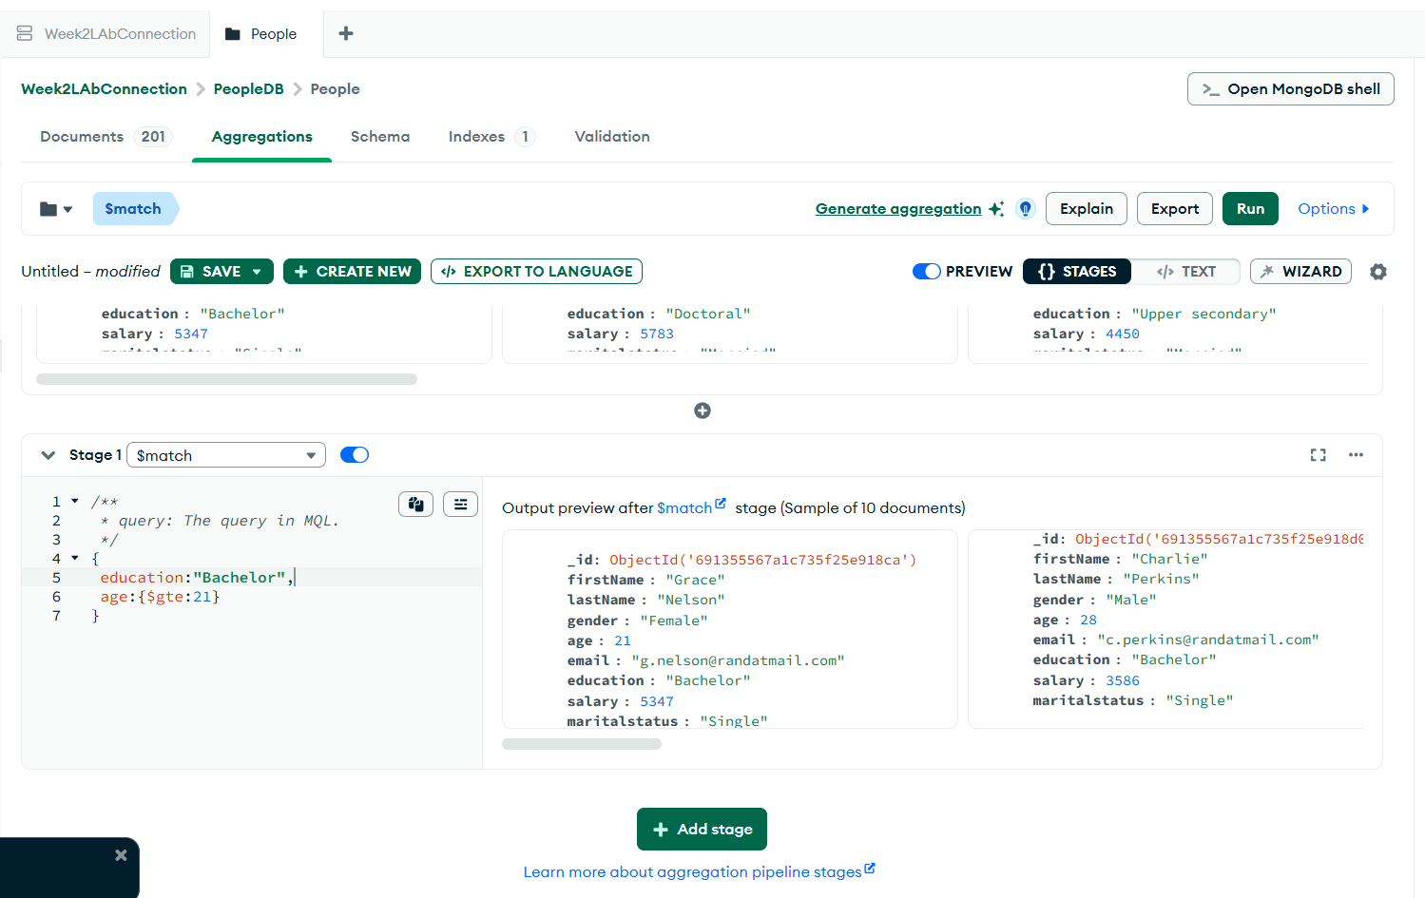
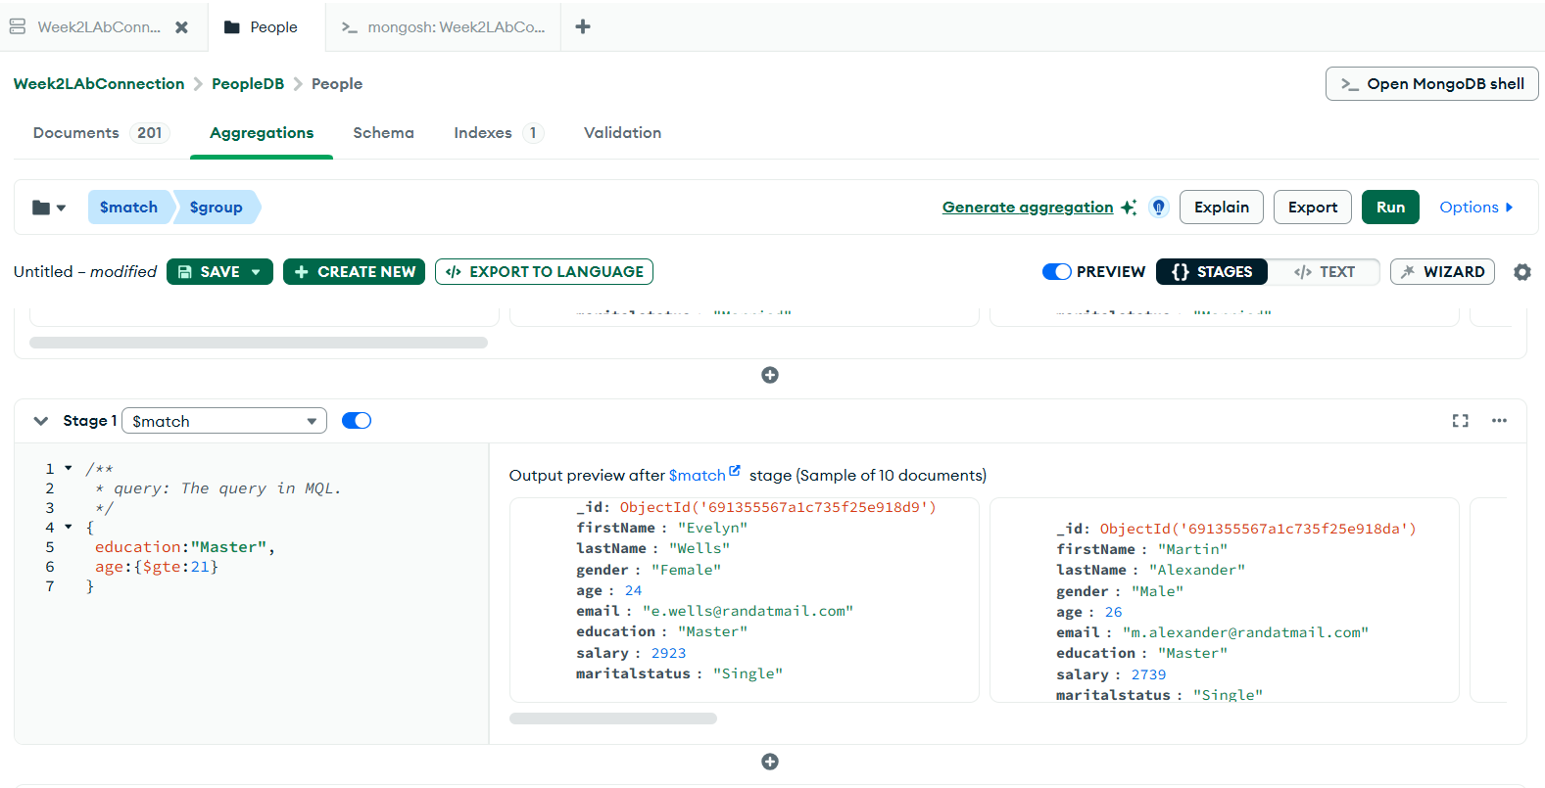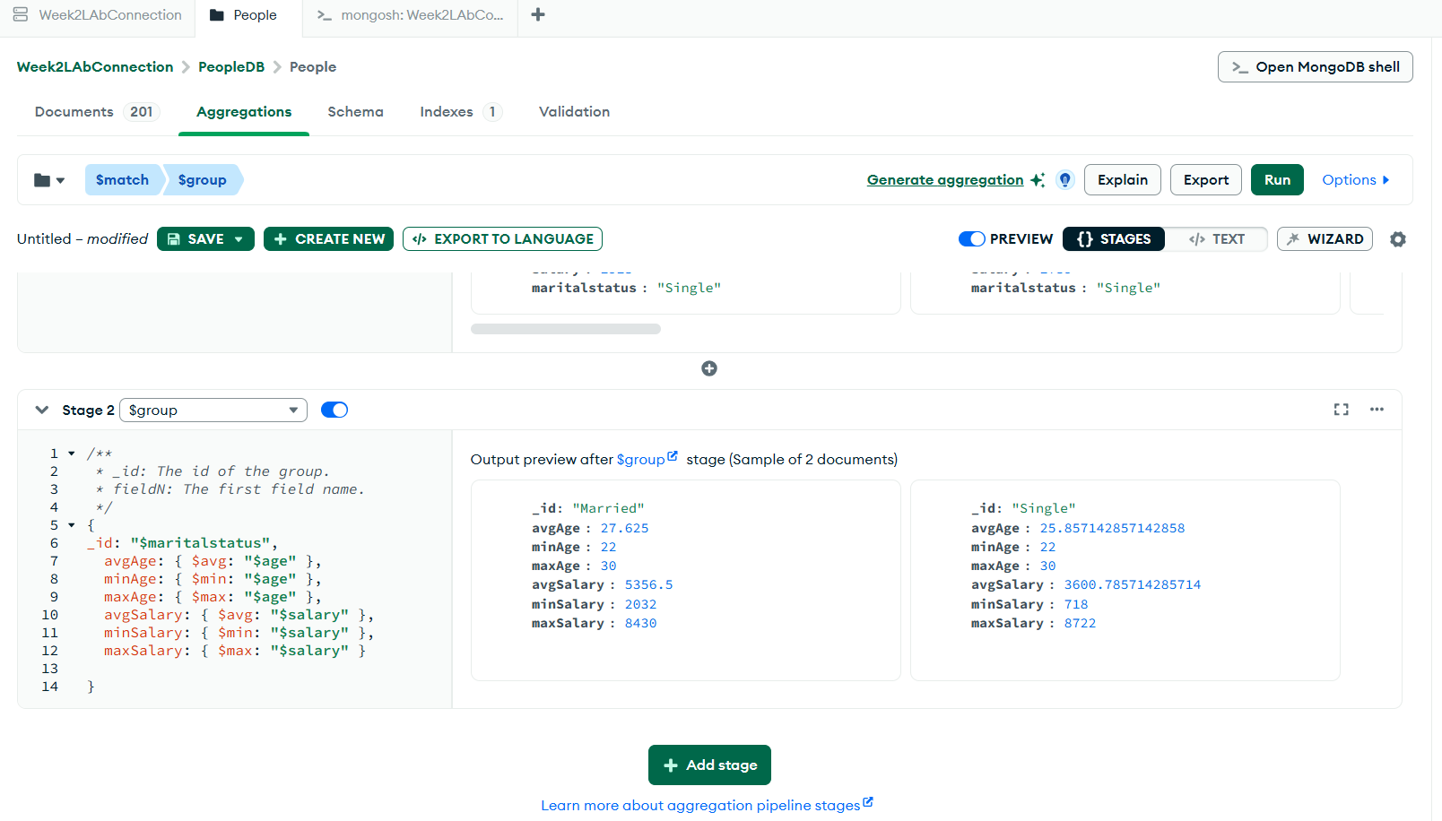
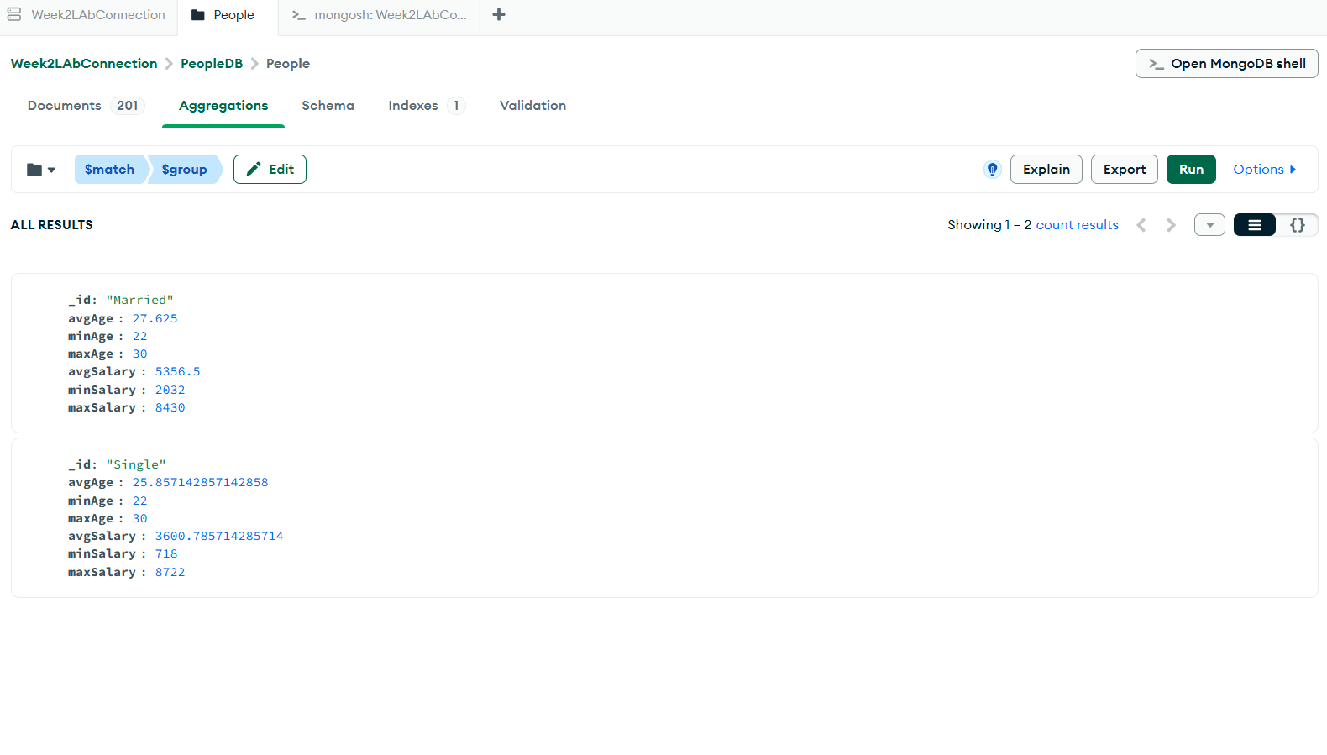
In Week 2’s lab, I learned how to manage and manipulate data using MongoDB Compass. I created a database named PeopleDB with a collection called people and imported data from a CSV file. I practiced inserting, updating, and deleting documents, which helped me understand how to manage records and ensure data integrity within a NoSQL environment.

This also introduced me to aggregation pipelines, where I used stages like $match and $group to filter data. I was able to calculate average, minimum, and maximum age and salary, grouped by gender, age, and marital status, as well as count married and unmarried individuals. This exercise demonstrated how MongoDB can perform complex data analysis without multiple queries or joins.

